1. **Checkout Github Medplat Project**

Checkout project from <https://github.com/ArgusoftOpen/medplat>

1. **Start Server :**

To **START** the Backend server and ui execute below command from terminal

**docker-compose up --build**

It will up the server on localhost port 80 . <http://127.0.0.1/medplat-ui/>

If docker is hosted on public ip/domain it can be accessed by public ip/domain

Note: Above command will create two docker images and create instance from both.

1. **STOP server :**

To **STOP** backend server and UI execute following command from terminal

**docker-compose down**

1. **Check docker status :**

To Display list of images and instances following commands can be used

**docker images**

**docker ps**

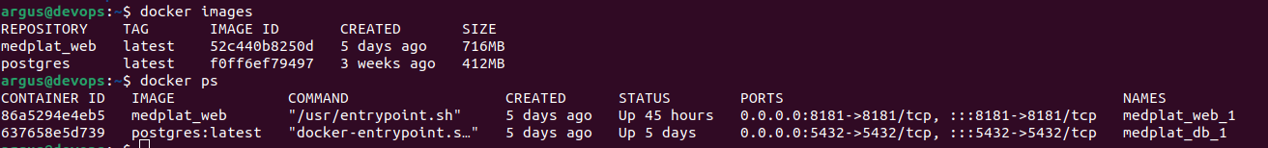

1. **Build Mobile App :**